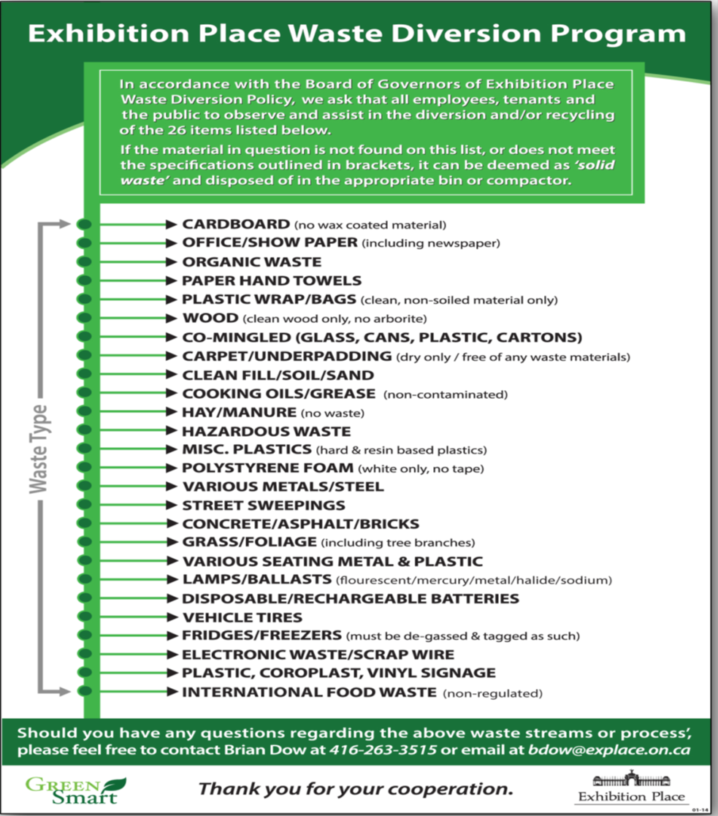

Should you have any questions regarding the above waste streams or process, please feel free to contact Carla Howman at *416-892-3544*or email at *CHowman@explace.on.ca*